Figure 1System Architecture

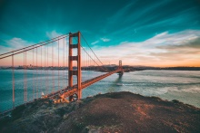

Web Interface

Image Dataset

Feature Extraction

Query Engine

Feature Matches

Best Location Match

Image

Flow of System:

Original Image which we want to compare

Image Dataset

Converted to Grey Scale

Resize and flatten

Calculate Intensity Difference and returns the diff

Calculate Hamming distance for two images

If it less than .20 (or may set to .10) then adding to matching dictionary

Find Matching images

Get the best Location Match

Display output to User